**Some important and commonly used functions of OpenCV:**

Image.shape:

It returns a tuple of number of rows, columns and channels of the image.

Image.size:

It returns the total number of pixel which can be accessed in the image.

Image.dtype:

It returns the datatype of the image.

**Python code:**

#import openCV library

import cv2

img = cv2.imread('test.jpg',1);

#img.shape returns a tuple (numbers of rows, number of columns, number of channels) in the image

print(img.shape);

#img.size returns the total number of pixels in the image

print(img.size);

#img.dtype returns the datatype of image

print(img.dtype);

Console:

(183, 275, 3)

150975

uint8

cv2.split():

cv2.split(image) is used to split the given image into its different channels. It has only one argument i.e., the image which we want to split.

cv2.merge():

cv2.merge() is used to merge the images into one image. If we merge the different channel of an image together then we will obtain the original image again.

**Python code:**

#import openCV library

import cv2

img = cv2.imread('test.jpg',1);

#original image

cv2.imshow('image1',img);

b,g,r = cv2.split(img);

#splitted image( channel b is shown)

cv2.imshow('image2',b);

img2 = cv2.merge((b,g,r));

#image after merging all the channels again

cv2.imshow('image3',img2);

cv2.waitKey(10000);

cv2.destroyAllWindows();

Output:

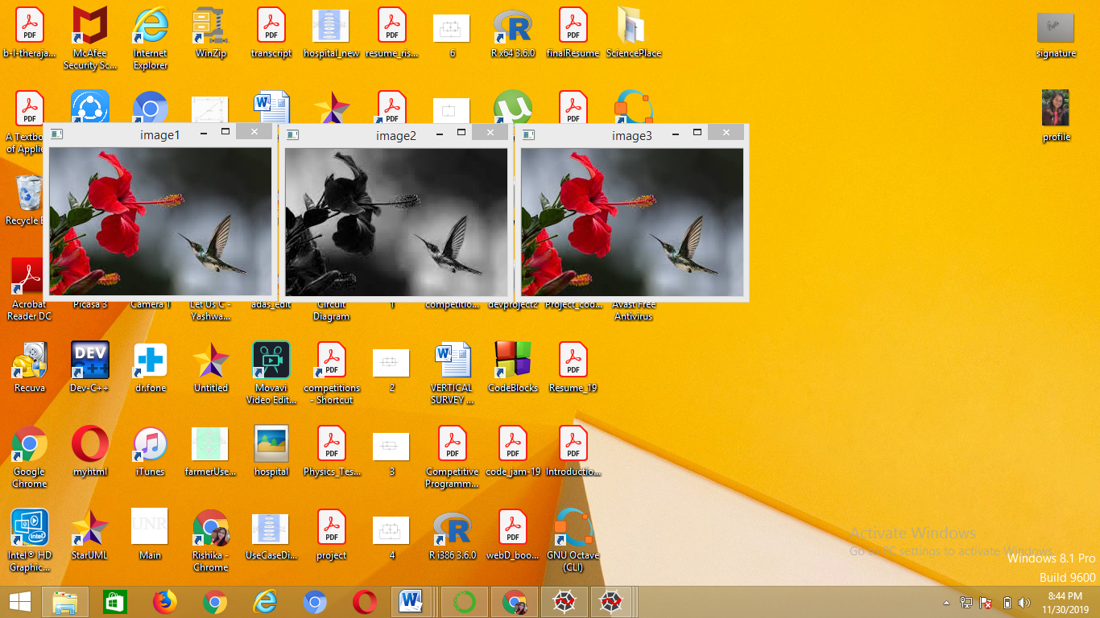

How to crop an image:

As the image is represented as a multidimensional matrix, hence we can use slicing to crop an image.

Example:

**Python code:**

#import openCV library

import cv2

img = cv2.imread('test.jpg',1);

#original image

cv2.imshow('image1',img);

img2 = img[0:100,50:200];

#image after slicing

cv2.imshow('image2',img2);

cv2.waitKey(30000);

cv2.destroyAllWindows();

Output:

